SAM   
It is an extension to Cloud formation – used specifically to define serverless applications.  
  
It gives you a simplified syntax for defining these serverless resources.  
Could be APIs, Lambda functions, Dynamo Db tables etc.  
  
It also has its own command line interface called the SAM CLI.  
  
We use the SAM cli to package the deployment code, upload it to S3, and deploy your serverless application using cloud formation.  
  
1. Command in SAM cli.

SAM Package :  
It creates a zip file of your code and dependencies and uploads it to Amazon S3.  
It outputs a SAM compatible template.  
  
Example :  
sam package \  
 --template-file ./mytemplate.yml \  
 --output-template-file sam-template.yml \  
 --s3-bucket s3bucketname  
  
SAM Deploy.  
This takes input the SAM template created above.  
We mention the name of the cloud formation stack.  
capabilities parameter : This enables cloud formation to create an iam role to allow the function to execute.  
  
sam deploy \  
 --template-file sam-template.yml \  
 --stack-name mystack \  
 --capabilities CAPABILITY_IAM  
  
2. CLOUD FORMATION AND SAM LAB.

Here we will deploy a lambda function using cloud formation and SAM.  
  
2.1   
Install the SAM cli – It depends on OS.  
  
  
  
2.2 Lets create a S3 bucket which we use to upload the lambda deployment package.  
  
Firstly we have a user with Administrator permissions – either the policy is attached to the user directly or this user is added to a group with that ‘administrator access’ policy. Make sure to have the Access key id and secret access key available to the user.  
  
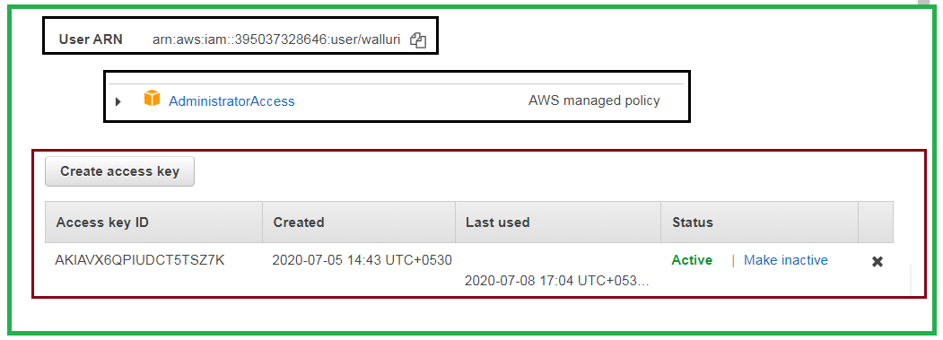  
  
Create a bucket. This is going to be the bucket to which we shall be uploading our lambda deployment packages after we created them.  
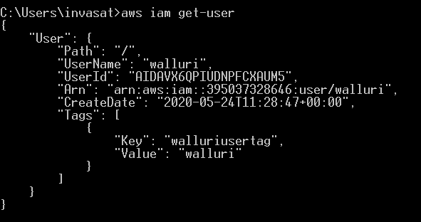  
  
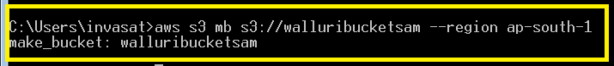  
  
Lambda function.  
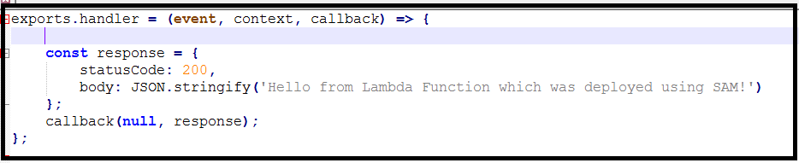  
  
Cloud Formation Template.  
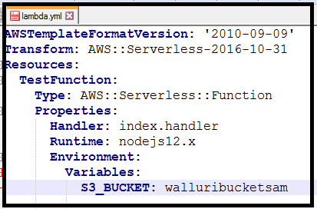  
  
Transform : This parameter defines this as a SAM deployment.  
AWS::Serverless : This tell cloud formation that this is going to be using SAM.  
  
The resource we are going to be provisioning is going to be a serverless function.  
  
2.3   
Package The deployment and upload to the S3 bucket using package command.  
sam package   
--template-file ./lambda.yml   
--output-template-file sam-template.yml  
--s3-bucket walluribucketsam  
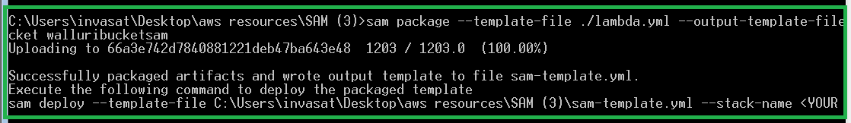  
  
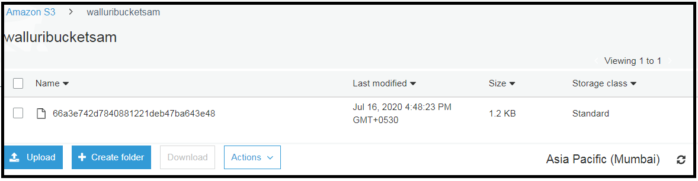  
  
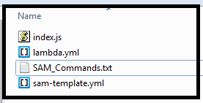  
  
  
sam deploy \  
--template-file sam-template.yml \  
--stack-name mystack \  
--capabilities CAPABILITY_IAM  
  
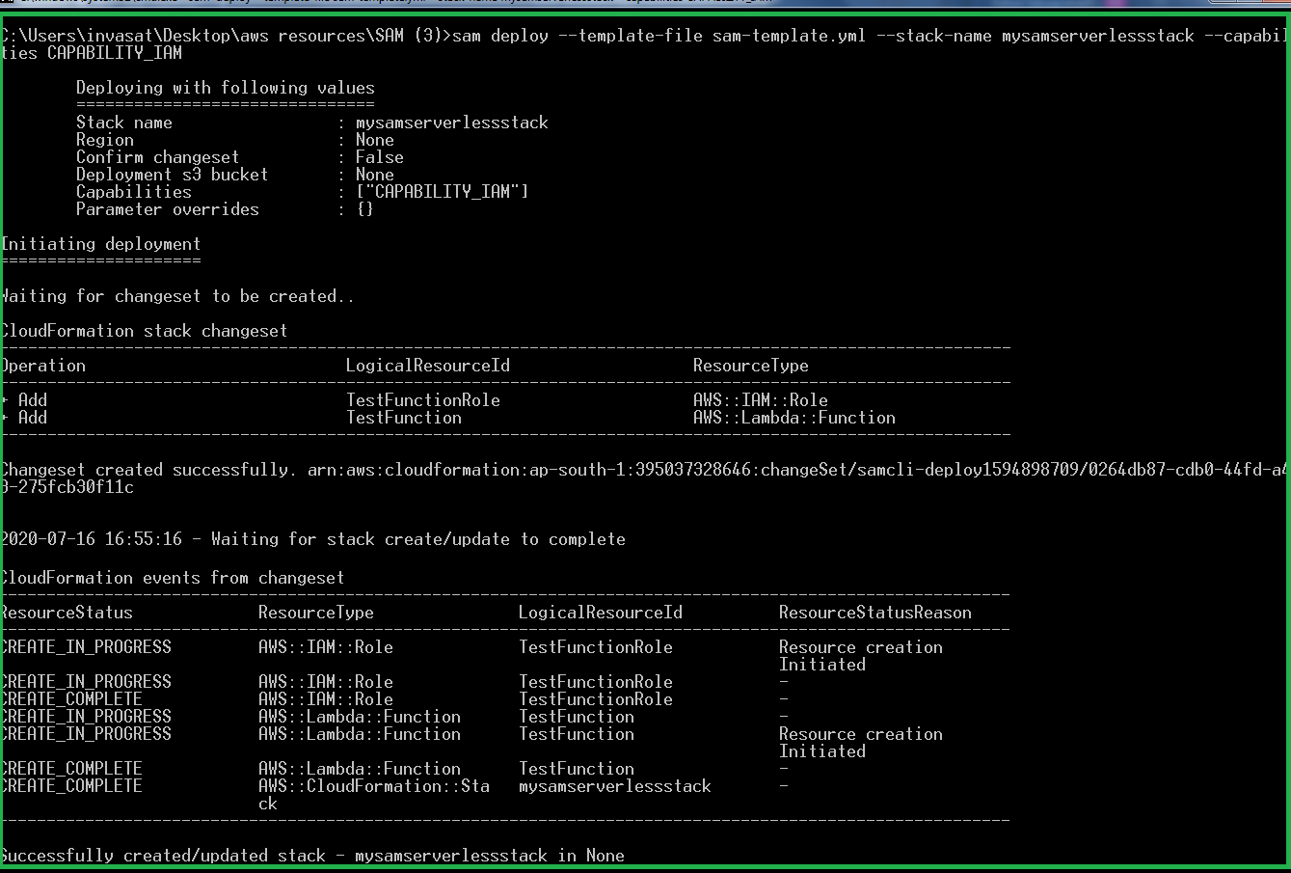  
  
2.4 Test to see if the serverless deployment worked fine.